| Please choose a lesson, or type 0 to return to course menu.

1: Principles of Analytic Graphs 2: Exploratory Graphs

3: Graphics Devices in R 4: Plotting Systems

5: Base Plotting System 6: Lattice Plotting System

7: Working with Colors 8: GGPlot2 Part1

9: GGPlot2 Part2 10: GGPlot2 Extras

11: Hierarchical Clustering 12: K Means Clustering

13: Dimension Reduction 14: Clustering Example

15: CaseStudy

Selection: 4

| Attemping to load lesson dependencies...

| Package ‘ggplot2’ loaded correctly!

| Package ‘lattice’ loaded correctly!

| Package ‘jpeg’ loaded correctly!

| | 0%

| Plotting_Systems. (Slides for this and other Data Science courses may be found at github

| https://github.com/DataScienceSpecialization/courses/. If you care to use them, they must be

| downloaded as a zip file and viewed locally. This lesson corresponds to

| 04_ExploratoryAnalysis/PlottingSystems.)

...

|== | 3%

| In this lesson, we'll give you a brief overview of the three plotting systems in R, their

| differences, strengths, and weaknesses. We'll only cover the basics here to give you a general idea

| of the systems and in later lessons we'll cover each system in more depth.

...

|===== | 5%

| The first plotting system is the Base Plotting System which comes with R. It's the oldest system

| which uses a simple "Artist's palette" model. What this means is that you start with a blank canvas

| and build your plot up from there, step by step.

...

|======= | 8%

| Usually you start with a plot function (or something similar), then you use annotation functions to

| add to or modify your plot. R provides many annotating functions such as text, lines, points, and

| axis. R provides documentation for each of these. They all add to an already existing plot.

...

|========== | 11%

| What do you think is a disadvantage of the Base Plotting System?

1: A complicated plot is a series of simple R commands

2: You can't go back once a plot has started

3: It mirrors how we think of building plots and analyzing data

4: It's intuitive and exploratory

Selection: 2

| You are quite good my friend!

|============ | 14%

| Yes! The base system is very intuitive and easy to use when you're starting to do exploratory

| graphing and looking for a research direction. You can't go backwards, though, say, if you need to

| readjust margins or fix a misspelled a caption. A finished plot will be a series of R commands, so

| it's difficult to translate a finished plot into a different system.

...

|=============== | 16%

| We've loaded the dataset cars for you to demonstrate how easy it is to plot. First, use the R

| command head with cars as an argument to see what the data looks like.

> head(cars)

speed dist

1 4 2

2 4 10

3 7 4

4 7 22

5 8 16

6 9 10

| You are quite good my friend!

|================= | 19%

| So the dataset collates the speeds and distances needed to stop for 50 cars. This data was recorded

| in the 1920's.

...

|==================== | 22%

| We'll use the R command with which takes two arguments. The first specifies a dataset or

| environment in which to run the second argument, an R expression. This will save us a bit of

| typing. Try running the command with now using cars as the first argument and a call to plot as the

| second. The call to plot will take two arguments, speed and dist. Please specify them in that

| order.

> with(cars, plot(speed, dist))

| You nailed it! Good job!

|====================== | 24%

| Simple, right? You can see the relationship between the two variables, speed and distance. The

| first variable is plotted along the x-axis and the second along the y-axis.

...

|========================= | 27%

| Now we'll show you what the function text does. Run the command text with three arguments. The

| first two, x and y coordinates, specify the placement of the third argument, the text to be added

| to the plot. Let the first argument be mean(cars$speed), the second max(cars$dist), and the third

| the string "SWIRL rules!". Try it now.

> text(mean(cars$speed), max(cars$dist), "SWIRL rules!")

| You got it!

|=========================== | 30%

| Ain't it the truth?

...

|============================== | 32%

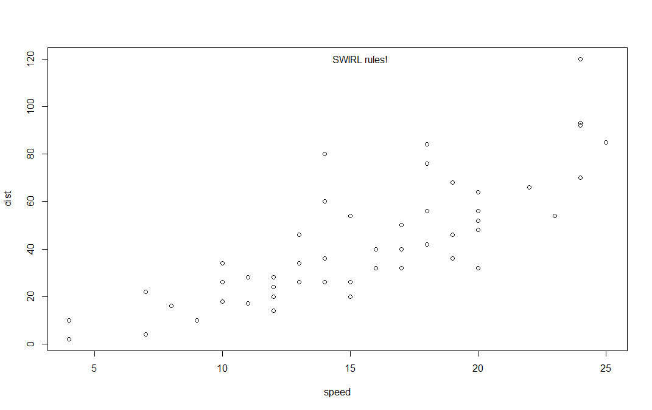

| Now we'll move on to the second plotting system, the Lattice System which comes in the package of

| the same name. Unlike the Base System, lattice plots are created with a single function call such

| as xyplot or bwplot. Margins and spacing are set automatically because the entire plot is specified

| at once.

...

|================================ | 35%

| The lattice system is most useful for conditioning types of plots which display how y changes with

| x across levels of z. The variable z might be a categorical variable of your data. This system is

| also good for putting many plots on a screen at once.

...

|=================================== | 38%

| The lattice system has several disadvantages. First, it is sometimes awkward to specify an entire

| plot in a single function call. Annotating a plot may not be especially intuitive. Second, using

| panel functions and subscripts is somewhat difficult and requires preparation. Finally, you cannot

| "add" to the plot once it is created as you can with the base system.

...

|===================================== | 41%

| As before, we've loaded some data for you in the variable state. This data comes with the lattice

| package and it concerns various characteristics of the 50 states in the U.S. Use the R command head

| to see the first few entries of state now.

> head(state)

Population Income Illiteracy Life.Exp Murder HS.Grad Frost Area region

Alabama 3615 3624 2.1 69.05 15.1 41.3 20 50708 South

Alaska 365 6315 1.5 69.31 11.3 66.7 152 566432 West

Arizona 2212 4530 1.8 70.55 7.8 58.1 15 113417 West

Arkansas 2110 3378 1.9 70.66 10.1 39.9 65 51945 South

California 21198 5114 1.1 71.71 10.3 62.6 20 156361 West

Colorado 2541 4884 0.7 72.06 6.8 63.9 166 103766 West

| Perseverance, that's the answer.

|======================================== | 43%

| As you can see state holds 9 pieces of information for each of the 50 states. The last variable,

| region, specifies a category for each state. Run the R command table with the argument state$region

| to see how many categories there are and how many states are in each.

> table(state$region)

Northeast South North Central West

9 16 12 13

| You got it!

|========================================== | 46%

| So there are 4 categories and the 50 states are sorted into them appropriately. Let's use the

| lattice command xyplot to see how life expectancy varies with income in each of the four regions.

...

|============================================= | 49%

| To do this we'll give xyplot 3 arguments. The first is the most complicated. It is this R formula,

| Life.Exp ~ Income | region, which indicates we're plotting life expectancy as it depends on income

| for each region. The second argument, data, is set equal to state. This allows us to use "Life.Exp"

| and "Income" in the formula instead of specifying the dataset state for each term (as in

| state$Income). The third argument, layout, is set equal to the two-long vector c(4,1). Run xyplot

| now with these three arguments.

> xyplot(Life.Exp ~ Income | region, data = state, layout = c(4, 1))

| All that practice is paying off!

|=============================================== | 51%

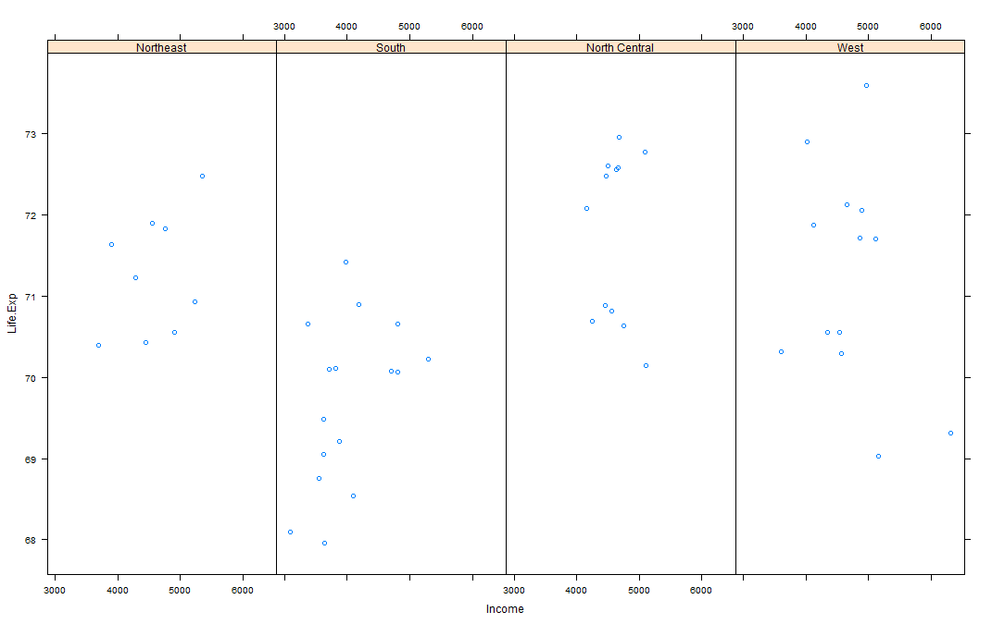

| We see the data for each of the 4 regions plotted in one row. Based on this plot, which region of

| the U.S. seems to have the shortest life expectancy?

1: South

2: Northeast

3: North Central

4: West

Selection: 1

| Nice work!

|================================================== | 54%

| Just for fun rerun the xyplot and this time set layout to the vector c(2,2). To save typing use the

| up arrow to recover the previous xyplot command.

> xyplot(Life.Exp ~ Income | region, data = state, layout = c(2, 2))

| Perseverance, that's the answer.

|==================================================== | 57%

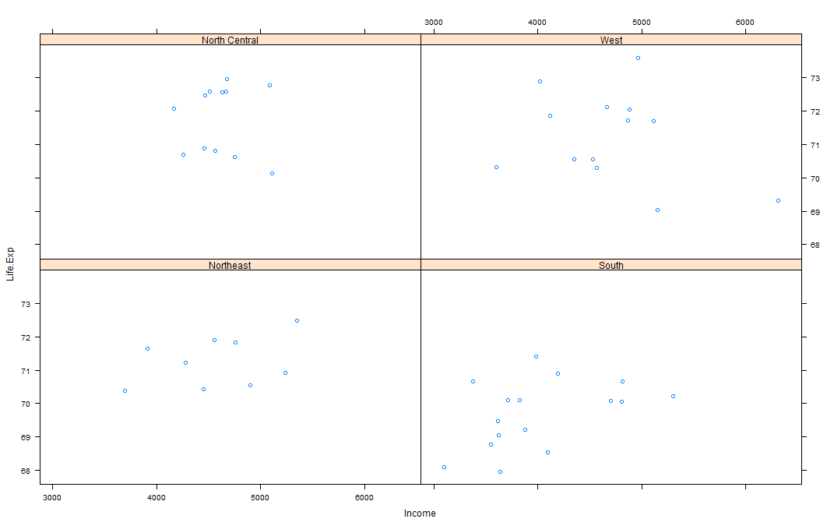

| See how the plot changed? No need for you to worry about margins or labels. The package took care

| of all that for you.

...

|======================================================= | 59%

| Now for the last plotting system, ggplot2, which is a hybrid of the base and lattice systems. It

| automatically deals with spacing, text, titles (as Lattice does) but also allows you to annotate by

| "adding" to a plot (as Base does), so it's the best of both worlds.

...

|========================================================= | 62%

| Although ggplot2 bears a superficial similarity to lattice, it's generally easier and more

| intuitive to use. Its default mode makes many choices for you but you can still customize a lot.

| The package is based on a "grammar of graphics" (hence the gg in the name), so you can control the

| aesthetics of your plots. For instance, you can plot conditioning graphs and panel plots as we did

| in the lattice example.

...

|============================================================ | 65%

| We'll see an example now of ggplot2 with a simple (single) command. As before, we've loaded a

| dataset for you from the ggplot2 package. This mpg data holds fuel economy data between 1999 and

| 2008 for 38 different models of cars. Run head with mpg as an argument so you get an idea of what

| the data looks like.

> head(mpg)

manufacturer model displ year cyl trans drv cty hwy fl class

1 audi a4 1.8 1999 4 auto(l5) f 18 29 p compact

2 audi a4 1.8 1999 4 manual(m5) f 21 29 p compact

3 audi a4 2.0 2008 4 manual(m6) f 20 31 p compact

4 audi a4 2.0 2008 4 auto(av) f 21 30 p compact

5 audi a4 2.8 1999 6 auto(l5) f 16 26 p compact

6 audi a4 2.8 1999 6 manual(m5) f 18 26 p compact

| You nailed it! Good job!

|============================================================== | 68%

| Looks complicated. Run dim with the argument mpg to see how big the dataset is.

> dim(mpg)

[1] 234 11

| You got it!

|================================================================= | 70%

| Holy cow! That's a lot of information for just 38 models of cars. Run the R command table with the

| argument mpg$model. This will tell us how many models of cars we're dealing with.

> table(mpg$model)

4runner 4wd a4 a4 quattro a6 quattro

6 7 8 3

altima c1500 suburban 2wd camry camry solara

6 5 7 7

caravan 2wd civic corolla corvette

11 9 5 5

dakota pickup 4wd durango 4wd expedition 2wd explorer 4wd

9 7 3 6

f150 pickup 4wd forester awd grand cherokee 4wd grand prix

7 6 8 5

gti impreza awd jetta k1500 tahoe 4wd

5 8 9 4

land cruiser wagon 4wd malibu maxima mountaineer 4wd

2 5 3 4

mustang navigator 2wd new beetle passat

9 3 6 7

pathfinder 4wd ram 1500 pickup 4wd range rover sonata

4 10 4 7

tiburon toyota tacoma 4wd

7 7

| Keep up the great work!

|=================================================================== | 73%

| Oh, there are 38 models. We're interested in the effect engine displacement (displ) has on highway

| gas mileage (hwy), so we'll use the ggplot2 command qplot to display this relationship. Run qplot

| now with three arguments. The first two are the variables displ and hwy we want to plot, and the

| third is the argument data set equal to mpg. As before, this allows us to avoid using the

| mpg$variable notation for the first two arguments.

> qplot(displ, hwy, data = mpg)

| You nailed it! Good job!

|====================================================================== | 76%

| Not surprisingly we see that the bigger the engine displacement the lower the gas mileage.

...

|======================================================================== | 78%

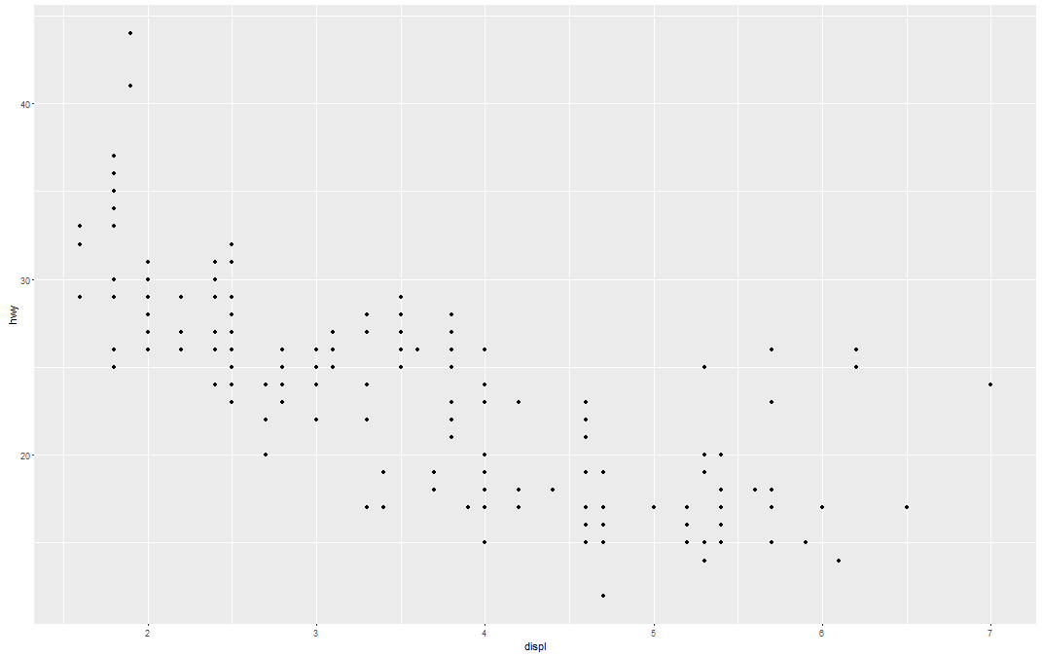

| Let's review!

...

|=========================================================================== | 81%

| Which R plotting system is based on an artist's palette?

1: ggplot2

2: base

3: lattice

4: Winsor&Newton

Selection: 2

| Keep up the great work!

|============================================================================= | 84%

| Which R plotting system does NOT allow you to annotate plots with separate calls?

1: lattice

2: ggplot2

3: Winsor&Newton

4: base

Selection: 1

| That's a job well done!

|================================================================================ | 86%

| Which R plotting system combines the best features of the other two?

1: ggplot2

2: base

3: lattice

4: Winsor&Newton

Selection: 1

| Nice work!

|================================================================================== | 89%

| Which R plotting system uses a graphics grammar?

1: ggplot2

2: Winsor&Newton

3: base

4: lattice

Selection: 1

| Perseverance, that's the answer.

|===================================================================================== | 92%

| Which R plotting system forces you to make your entire plot with one call?

1: Winsor&Newton

2: ggplot2

3: lattice

4: base

Selection: 3

| You are amazing!

|======================================================================================= | 95%

| Which of the following sells high quality artists' brushes?

1: Winsor&Newton

2: base

3: lattice

4: ggplot2

Selection: 1

| That's correct!

|========================================================================================== | 97%

| Congrats! You've concluded this plotting lesson. We hope you didn't find it plodding.

...

|============================================================================================| 100%